ITROOS Business Continuity

ITROOS
Business Continuity
Features:
• Complete end-to-end management of backups
• Block-level encryption
• Continuous Data Protection technology
• Fully-managed & monitored
• Cloud replication
• Off-site virtualization

For more information, please contact us:
info@itroos.net
051-2112141
www.itroos.net

Fully Managed Backup & Disaster Recovery
If the power in your office fails tonight, and all of your computers crash, how quickly can you recover? And more importantly, at what cost? According to the U.S. Department of Labor, 93% of companies that experience a disaster go out of business within 5 years – even if they can recover in the short term.

We’re here to ensure your business doesn’t become another statistic. Our business continuity solution is about more than just backup – it’s designed to quickly revive your network following any unplanned downtime, and ensure your employees are operating productively in almost no time at all.

Unparalleled Peace of Mind
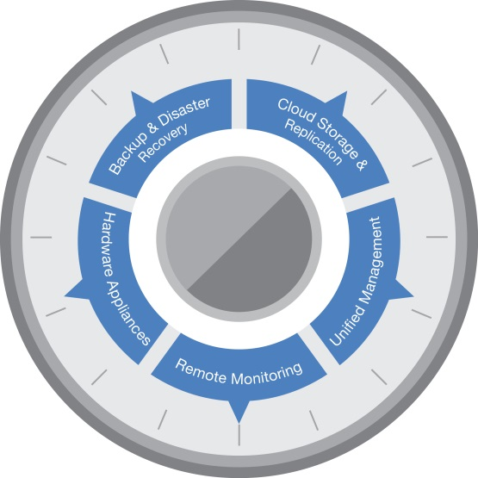
In today’s always-on business landscape, maintaining an effective backup and disaster recovery (BDR) strategy is becoming more important than ever before. Data is playing an increasingly critical role in decision-making processes, and the costs and risks associated with downtime are skyrocketing – not to mention the damage your brand and reputation can suffer in the event of a disaster.

Your Company’s business continuity solution includes features like continuous data protection, cloud-based replication and recovery, and more – all for one low fixed monthly price per protected server.

What does that mean? It means you can rest easy knowing that your critical data, emails, reports, and other information are all protected, backed up and securely tucked away until you need them.
Direct Support
Having a backup appliance in place is only the first step in a successful business continuity strategy. To minimize the risk of data loss as much as possible, you’ll want to have technicians proactively monitoring the entire backup process to ensure things are working as expected.

That’s why we’ve got a dedicated team keeping a watchful eye over your protected servers, ready to jump into action should any problems arise. And if the worst should happen, don’t worry – we’ll have you back up and running quickly.

